**What is software? what is software engineering?**

Ans = software is a set of instruction,data or programs used to operate computers ands execute specific tasks.software engineering is the application of principles used in the field of engineering.

**Explain types of software?**

Ans = there are four types of software application software,system software,driver software,middle ware,programming software.

Application software that includes with system like office suites graphic software database and database management programs.example of that Microsoft office,paint,powerpiont.

System software = there are designd to run a computers programe and hardware system software coordinates activites and function of the hardware and software it controls the operations of the computers hardware and provides an environment or platform for all the other type of software to work in example of is notepad,calculator etc.

Driver software = also known as device drivers this software is often consider a type of sytem software.example includes software that comes with any nonstander hardware including specials games controllers as well as the software that enables stander hardware such as also storage devices

Middle ware= the term middle ware describes software that mediates between application ans system software or between two different kinds of application software for example Microsoft middleware enables Microsoft windows to talk to excel and word.

Programming software = computer programers use programing software to write code programming software and programing tools enable to develop write test and debug other software programs.

**What is SDLC? Explain each phase of SDLC**

Software development life cycle.

The sdlc refers to a methodology with clearly defined proceses for creating high quality software.there are different phase of sdlc planning ,analiys ,design ,implementation ,testing ,maintance. There are different phase of sdlc requirement gathering,analysis,designing,implementation,testing,maintenance.there are different types of envirnments in industry.the analysis and design environment,the development environment,the common build environment,the testing environment,the production environment.

**What is DFD? Create a DFD diagram on Flipkart**

A data flow diagram (DFD) is a graphical or visual representation using a standardized set of symbols and notations to describe a business's operations through

Data movment.

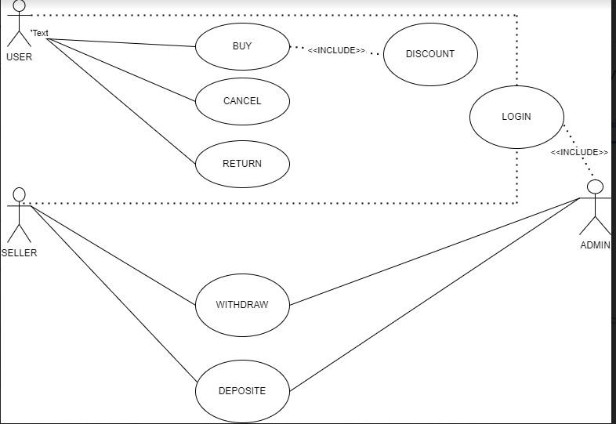

**What is Flow chart? Create a flowchart to make addition of two numbers**

A flow chart is a diagram that depicts a process,system or computer algorithm.they are widely used in a multiple field**.**

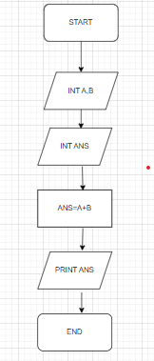

**What is Use case Diagram? Create a use-case on bill payment on paytm.**

A uml usecase diagram is the primary form of system software requirements for new software programe underdeveloped.

